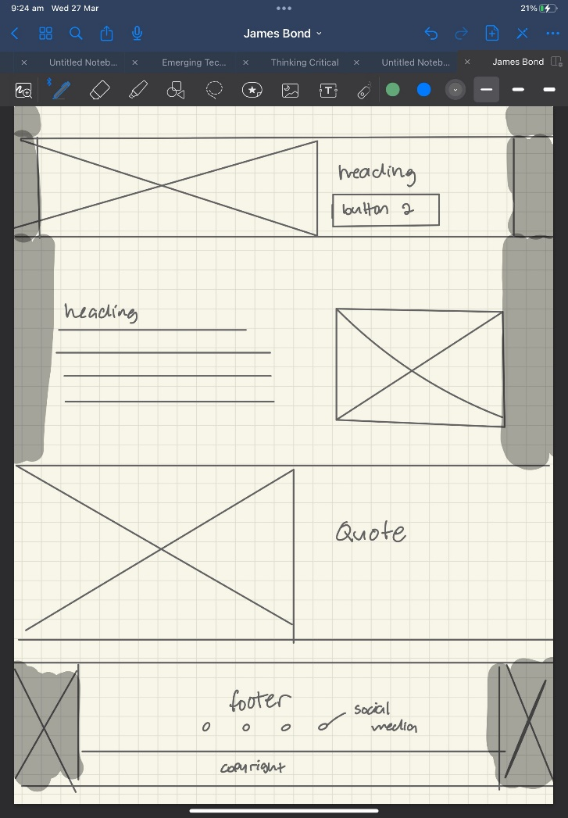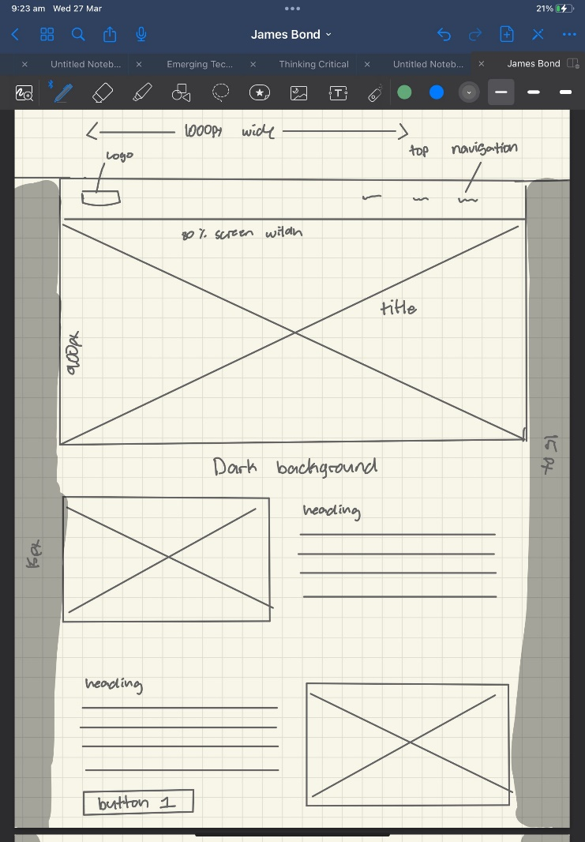Wireframe – James Bond

this is a template for James Bond website and will be used for all the pages.